# 

# 

# Experiment #2: Network Analysis Methods

## Objectives

* To analyze a resistive circuit using node or mesh analysis.
* To understand Thevenin’s and Norton’s theorems.
* To verify the superposition principle.

## Equipment

* Breadboard
* DC power supply
* Digital multimeter (DMM)

## Simulations

**Closed circuits:**

## 

## 

**Open circuit:**

Data from multimeters on the next page.

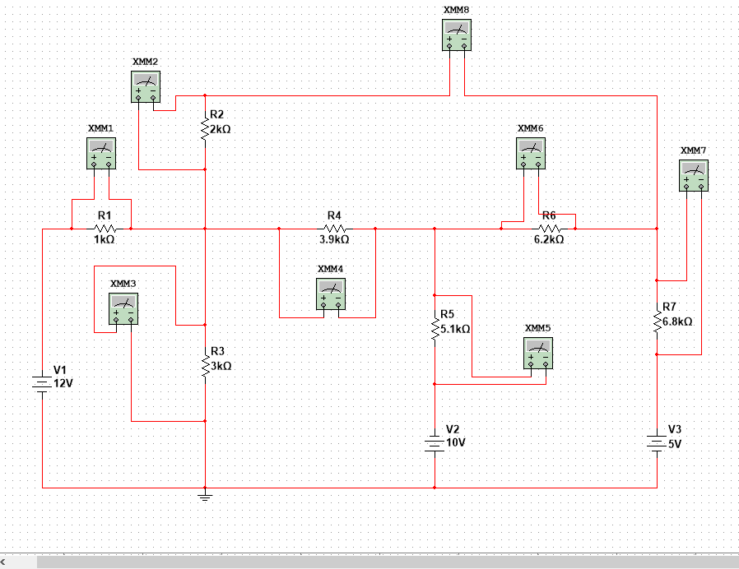

**Data for each multimeter on previous page. (Open Circuit)**

The number of the multimeter corresponds to the Resistor it is finding the voltage across. The values obtained by measuring and calculating values for R6 and R7 were different for our simulation and our values

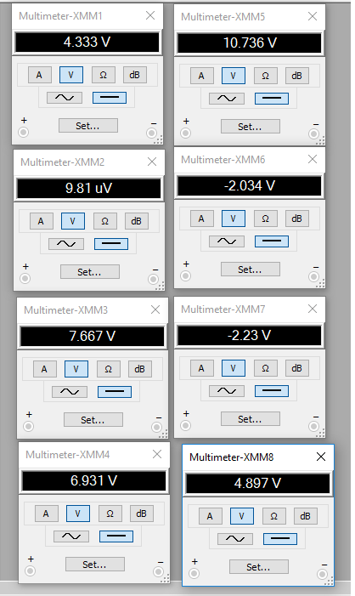

## Experiment

Build the circuit in Figure 3 – 1 on the breadboard. Refer to Section III in Experiment #1 to set the voltages sources in the circuit.

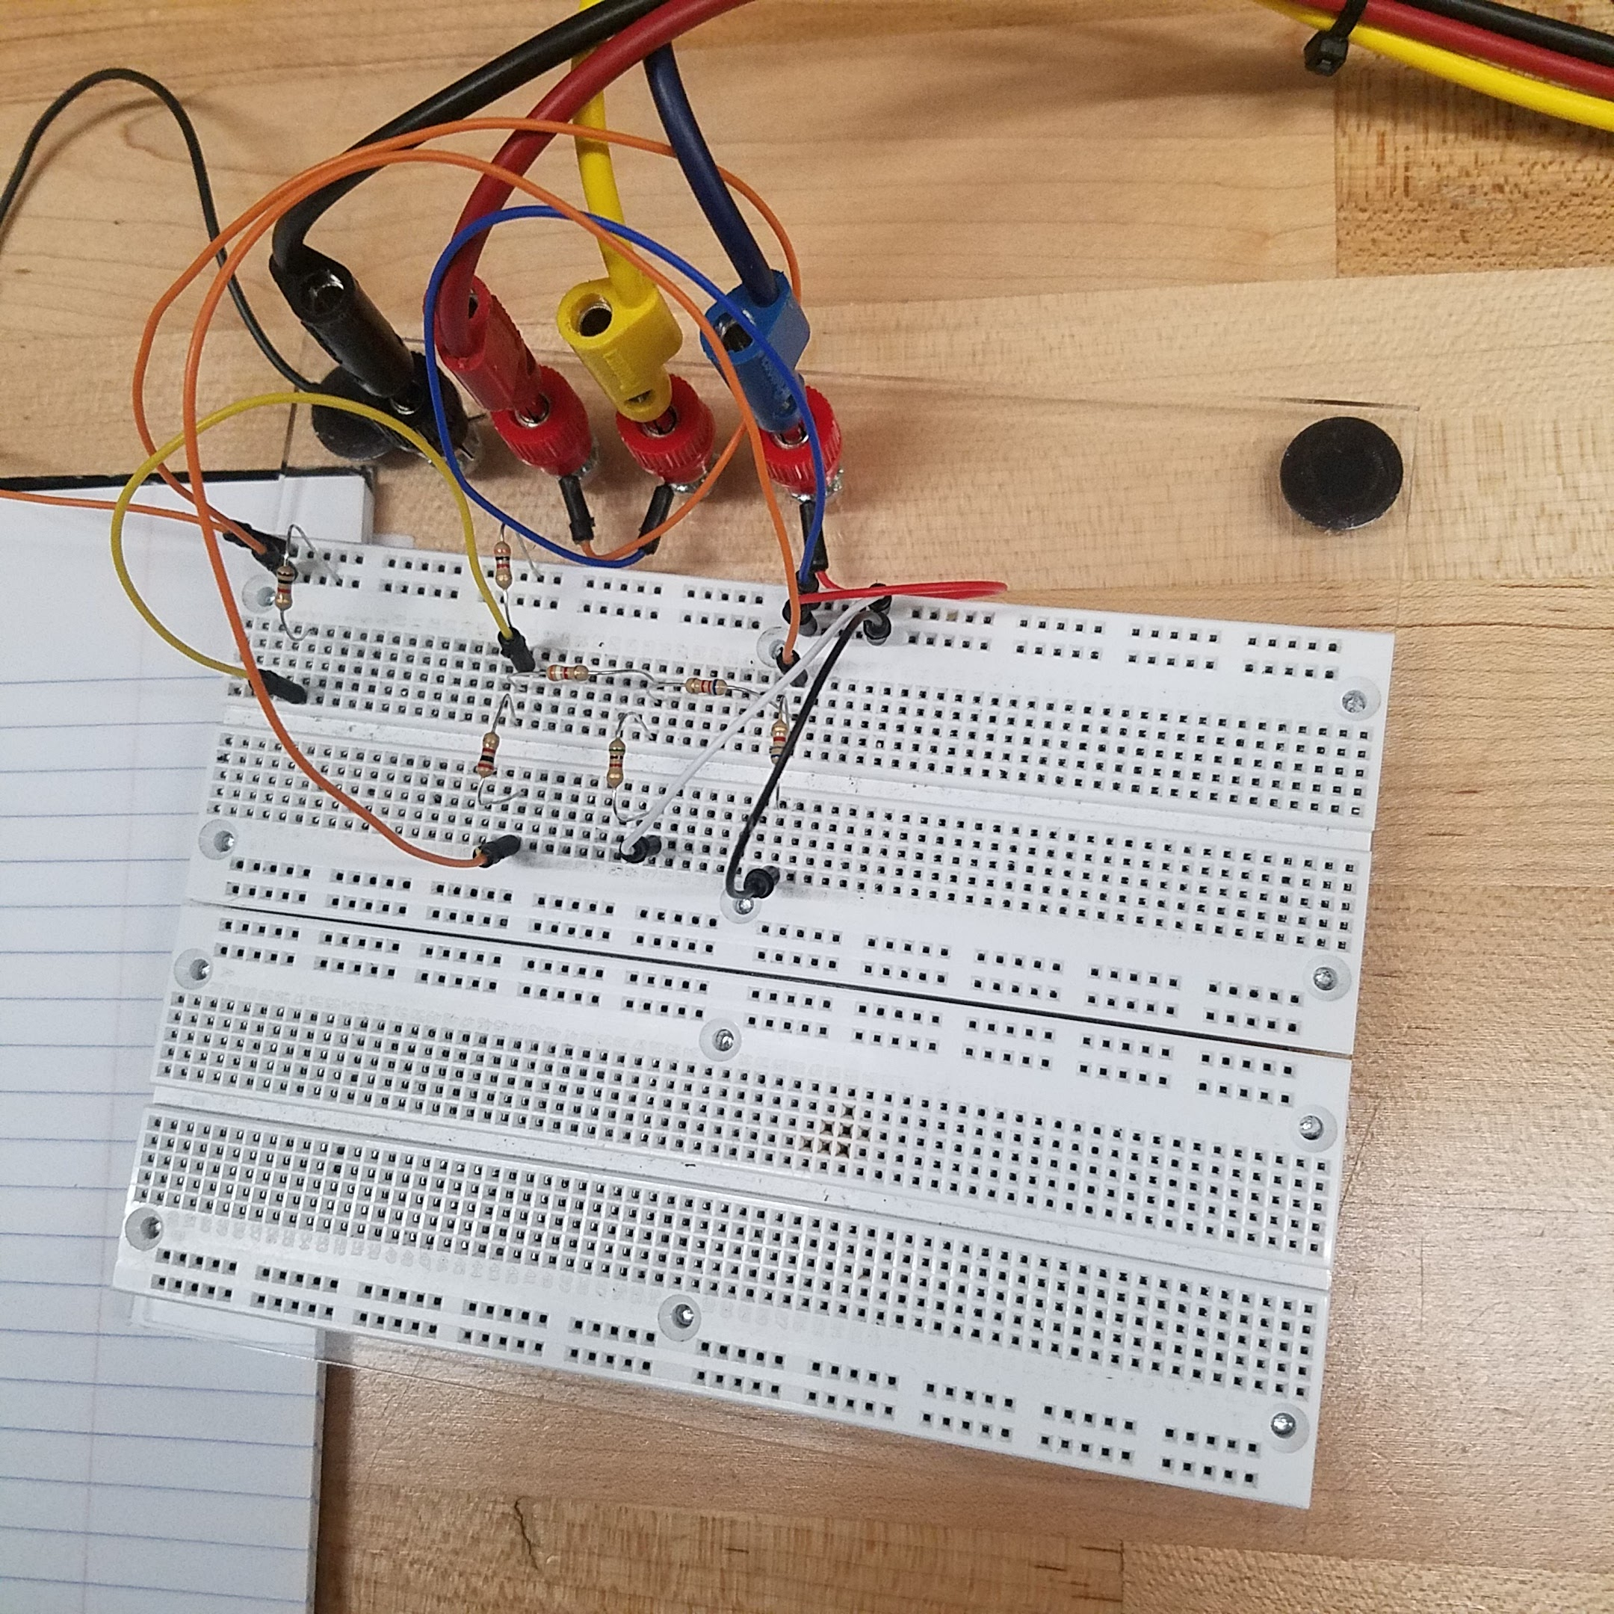

### A. Mesh analysis and nodal analysis

1. Short AB by connecting a wire across nodes A and B. Measure the voltage across each resistor and the current through AB, IAB. Refer to the BACKGROUND section in Experiment #1 for how to use DMM to read the voltage and current values.

|  |  |
| --- | --- |
| I AB | 0.8092 mA |

|  |  |  |  |  |
| --- | --- | --- | --- | --- |
| Resistor | Simulated Resistance | Resistance kΩ | Measured | Calculated |
| R1 | 1 kΩ | 0.987 kΩ | 4.723 V | 4.75 V |
| R2 | kΩ | 1.987 kΩ | 1.568 V | 1.64 V |
| R3 | kΩ | 2.84 kΩ | 7.146 V | 7.26 V |
| R4 | kΩ | 3.72 kΩ | 6.013 V | 6.04 V |
| R5 | kΩ | 4.801 kΩ | 10.984 V | 11.21 V |
| R6 | kΩ | 5.95 kΩ | 4.263 V | 4.40 V |
| R7 | kΩ | 6.69 kΩ | 0.683 V | 0.61 V |

1. Leave AB open. Measure the voltage across each resistor as well as the voltage across AB, VAB.
2. Compare the results from step 1 and 2 with those obtained from PREPARATION and SIMULATION sections.

|  |  |  |
| --- | --- | --- |
| Resistor | Measured | Simulated |
| R1 | 4.3537 V | 4.333V |
| R2 | 1.8 x 10^7 V | 9.81 x 10 ^ -7 V |
| R3 | 7.645 | 7.667 V |
| R4 | 6.968 | 6.931 V |
| R5 | 10.672 | 10.736 V |
| R6 | 4.374 | -2.034 V |
| R7 | 0.683 | -2.23 V |
| Vab | 5.015 | 4.897 V |

### B. Thevenin’s and Norton’s theorems

1. Set all voltage sources to zero by simply replacing them with wires. With AB open, measure the resistance between AB using DMM. What resistance value are you measuring here? How does this measured value compare to the values obtained earlier in the PREPARATION and SIMULATION?

|  |
| --- |
| Resistance between A and B with the circuit opened |
| 6.3184 kΩ |
| Value obtained during preparation |
| 6.1622 kΩ |

1. Connect all voltages sources back into the circuit. With a resistor connected between A and B, measure the current through this resistor using DMM for the following 3 resistor values:
   1. 1 kΩ,
   2. 2.2 kΩ,
   3. 4.7 kΩ.

|  |  |
| --- | --- |
| Resistor (Measured resistance) | Measured Currents through each resistor |
| 1 kΩ (0.9737 kΩ) | 0.688 mA |
| 2.2 kΩ (2.1522 kΩ) | 0.588 mA |
| 4.7 kΩ (4.503 kΩ) | 0.451 mA |

**1kΩ**

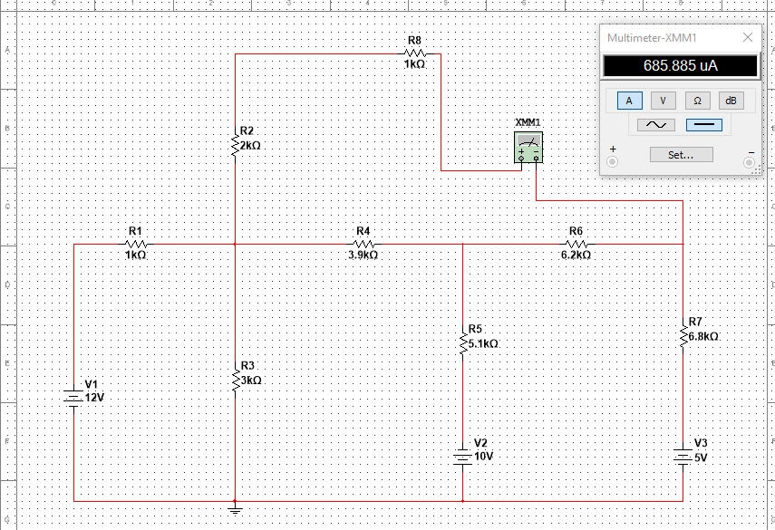

**2.2 kΩ**

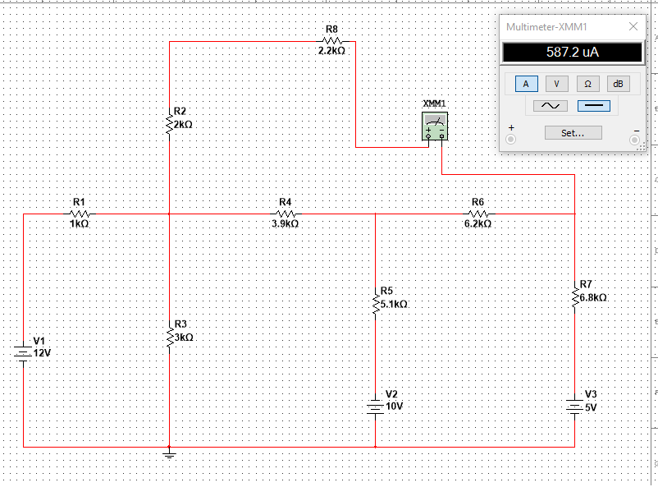

**4.7 kΩ**

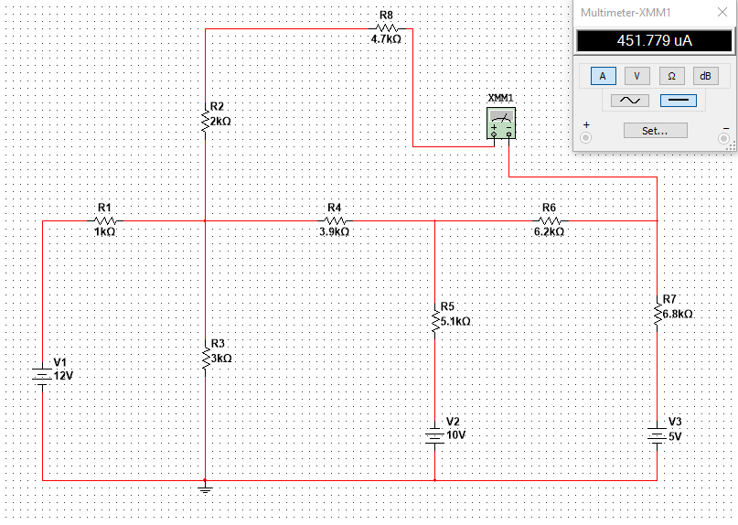

1. How do these current values compare to those obtained in the PREPARATION and SIMULATION

|  |  |  |
| --- | --- | --- |
| Currents through each resistor | Preparation | Simulation |
| 0.688 mA | 0.7055 mA | 0.685 mA |
| 0.588 mA | 0.6043 mA | 0.587 mA |
| 0.451 mA | 0.4695 mA | 0.451 mA |

### C. Superposition principle

1. With AB open, measure the voltage across AB, VAB for the following 3 cases:
   1. E1 is turned on while both E2 and E3 are turned off;

|  |  |
| --- | --- |
| VAB | 5.75 V |

* 1. E2 is turned on while both E1 and E3 are turned off;

|  |  |
| --- | --- |
| VAB | 1.395 V |

* 1. E3 is turned on while both E1 and E2 are turned off.

|  |  |
| --- | --- |
| VAB | -2.452 V |

1. Add the above three voltages. What have you discovered? Compare the results with those obtained in PREPARATION and SIMULATION.

|  |  |
| --- | --- |
| Vtotal | 5.75 V + 1.395 V - 2.452 V = 4.693 |

The value is very close to the total voltage found in the preparation

1. With AB open, measure the voltage across AB, VAB for the following 2 cases:
   1. E1 is turned on while both E2 and E3 are turned off;

|  |  |
| --- | --- |
| VAB | 5.74V |

* 1. both E2 and E3 are turned on while E1 is turned off.

|  |  |
| --- | --- |
| VAB | -1.124 V |

1. Add the above two voltages. What have you discovered? Provide a detailed explanation of your discovery.

|  |  |
| --- | --- |
| Vtotal | 5.74 V - 1.124 V = 4.616 V |

Very close to a our total voltage found in preparation

1. With AB open, measure the voltage across AB, VAB for the following 3 cases:
   1. both E1 and E2 are turned on while E3 is turned off;

|  |  |
| --- | --- |
| VAB | 6.954 V |

* 1. both E1 and E3 are turned on while E2 is turned off;

|  |  |
| --- | --- |
| VAB | -3.270 V |

* 1. both E2 and E3 are turned on while E1 is turned off.

|  |  |
| --- | --- |
| VAB | 1.115 V |

All three of the values are very close to the measured voltage, proving that we can use the superposition principle to find the voltage or current we need at any element in the circuit. We can do this by shutting off each independent source except for one, Find the voltage of the element then do the same with each independent source turned on alone, and sum those voltages.

|  |  |
| --- | --- |
| Vtotal | 4.799V |

### D. Design Problem

For all the designed circuits in Figure 3 – 3, set the input voltage to be 9V and measure the output voltage. Compare all measured values with the calculated and simulated results.

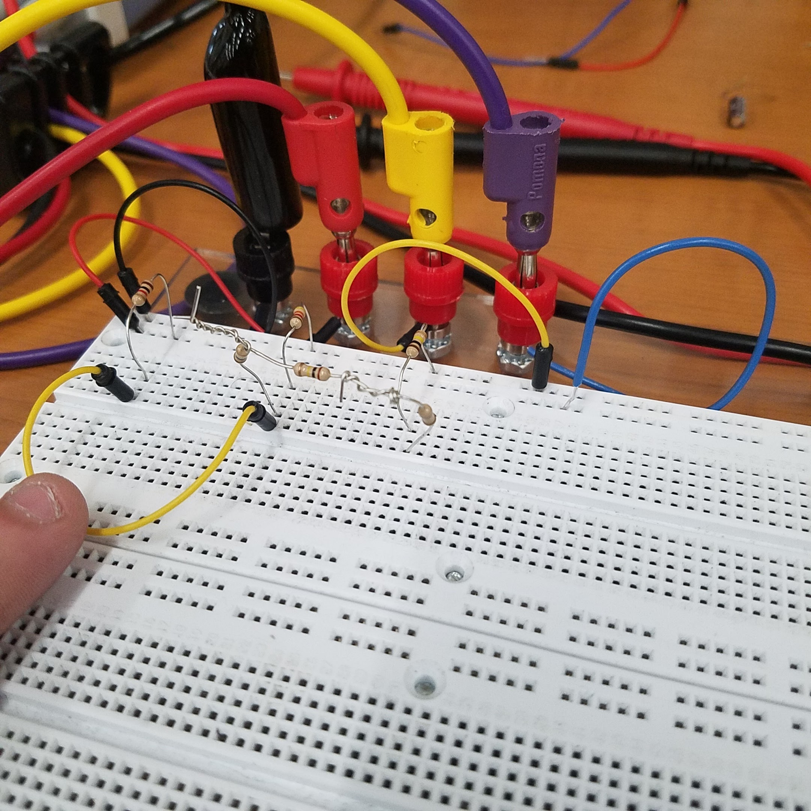

**Circuit A**

The ratio of resistance calculated in the prelab is Vy = .8Vx

Vx is our input voltage, which in each case will be 9.

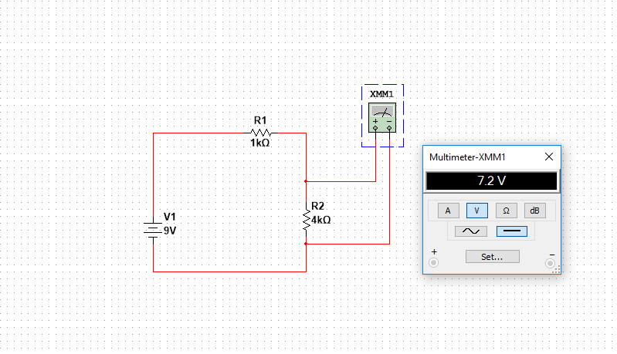

|  |  |  |
| --- | --- | --- |
|  | Measured | Simulated |
| R 1kΩ | 0.989 kΩ | 1 kΩ |
| R 4kΩ | 4.15 kΩ | 4 kΩ |
| Vy | 7.236 V | 7.2 V |

**Circuit B**

The ratio of resistance calculated in the prelab is Vz = .25Vy

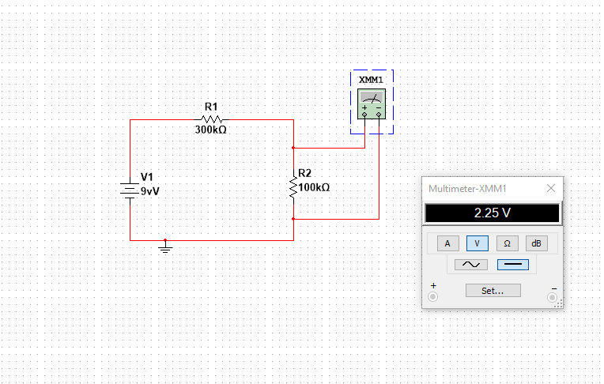

|  |  |  |
| --- | --- | --- |
|  | Measured | Simulated |
| R 300 kΩ | 0.989 kΩ | 300 kΩ |
| R 100 kΩ | 4.15 kΩ | 100 kΩ |
| Vz | 2.379 V | 2.25 V |

**Combination Voltage Divider Circuit**

The ratio of resistance calculated in the prelab is Vz = Vx(0.25)(0.8)

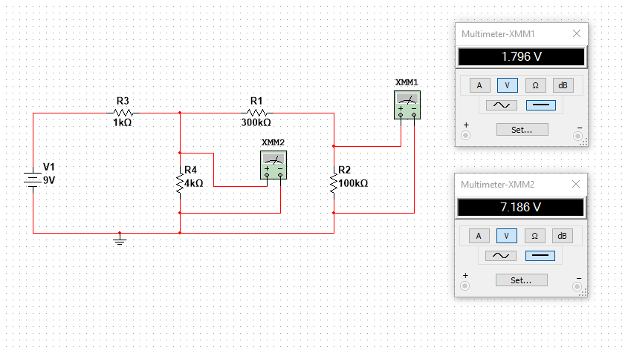

|  |  |  |
| --- | --- | --- |
|  | Measured | Simulated |
| Vz | 1.803 V | 1.796 V |

### Conclusions

In Conclusion, for this experiment we have applied node voltage network analysis as well as mesh current analysis to a circuit and confirmed these methods work for the analysis of an electrical system. We have shown the principle of superposition,which shows that if we have a linear circuit containing two or more independent sources, our voltage across an element can be obtained by algebraically adding all of voltages caused by, each independent source acting alone with all other sources turned off, as well as voltages sources replaced by short circuits (We can also apply the superposition principle to currents). Finally, we have shown that using a voltage divider circuit we can create different ratios of that input voltage to divide it up the way we would like.